## IBM-EPBL/IBM-Project-31325-1660199088

## SOLUTION ARCHITECTURE - DEEP LEARNING FUNDUS IMAGE ANALYSIS FOR EARLY DETECTION OF DIABETIC RETINOPATHY.

## TEAM MEMBERS :

## 913119106039 – Jerolin Futina J.B

## 913119106048 – Kaviya Prabha M.P

## 913119106075 - Pandia Abinaya.P

## 913119106099 – Shanmuga Priya.R

**Diabetic Retinopathy :**

Diabetic Retinopathy (DR) is a common complication of diabetes mellitus, which causes lesions on the retina that affect vision. If it is not detected early, it can lead to blindness. Unfortunately, DR is not a reversible process, and treatment only sustains vision. DR early detection and treatment can significantly reduce the risk of vision loss. The manual diagnosis process of DR retina fundus images by ophthalmologists is time, effort and cost-consuming and prone to misdiagnosis unlike computer-aided diagnosis systems.

**Project Flow**

* The user interacts with the UI (User Interface) to choose the image.
* The chosen image analyzed by the model which is integrated with flask application.
* The Xception Model analyzes the image, then the prediction is showcased on the Flask UI.

**Technical Architecture**

[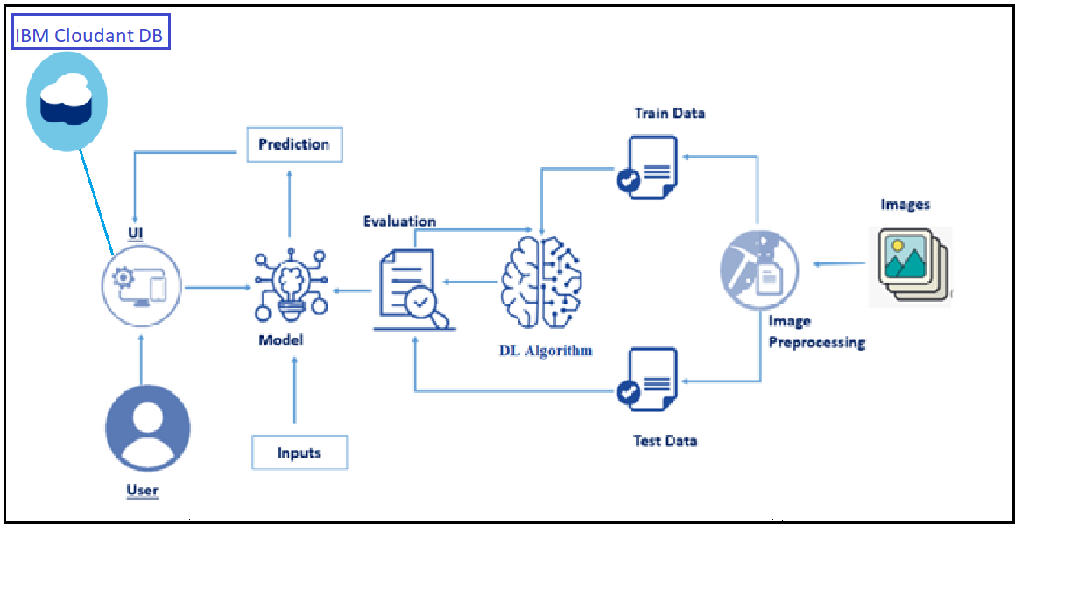](https://user-images.githubusercontent.com/78421729/190216164-f6310103-26b1-41e1-8715-4a1ac281ba89.png)

# Implementation Brief

We have to use multi layer neural networks as deep NN. Due to the fact that our data’s structure is Image, the best type of neural network satisfying our goal is Convolutional Neural Networks. As we have to do for most of data, normalization does an important role in our process. Before doing any tasks, pre-processing images (our dataset) is highly recommended. Consequently better accuracy will achieved by pre-processed data. After doing pre-processing and normalizing, prepared dataset could be used as input of our deep convolutional neural network. Then deep NN will be run and fit to our data and the result will be produced by that. This report will cover step by step how this deep convolutional network be implemented.

# Pre-processing Data

As it is mentioned before pre-processing play an important role in our goal. Hence, we use Image Processing techniques to pre-process our dataset. For this, mentioned techniques has been used to find and bold the intensity of the abnormal areas and pieces for decreasing the effect of outlayers. Some of images have abnormal structures. For instance optic disk and vessels are abnormal. Note that before trying to solve the problem with grayscaled data, multi-channel images have been tested and results was not very reliable at all. As a consequent, using gray-scaled images was decided to use. After gray-scaled images prepared, next requirement is Normalization.

**Normalization**

By having pre-processed data, now data could be normalized easily by divide image intensities to 255 (image converted to gray-scale previously). Then normalized data have to be attached label for learning the network. Class labels are available in each image name in the first substring. Now pre-processed data have been normalized.

**Creating Deep Neural Network Model**

This Deep neural network is contained 7 layers which will be described. The first layer is Convolutional1D network with kernel size 5 and activation function relu. After pre-processing data we resized data which produce 256*256 gray-scaled image. So, our input shape is going to be (256,256, 1). Then we use MaxPooling to combine important features then Flatten and then dropout. At the end Dense(1) be used because we have binary classes [is diabetic or not].

**Running Model**

After doing all steps run the network and make sure that it works well for our solution. So, at first model has to compiled then it has to be fit and run then by passing test data, result will be generated then.